Chapter 5, Solution 35.

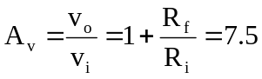 R_{f} = 6.5R_{i}

If R_{i} = 60 kΩ, R_{f} = 390 kΩ.

